PRACTICAL EXAM - SWD392 -FAL25
Date time:
Exam Code:

Question 1:
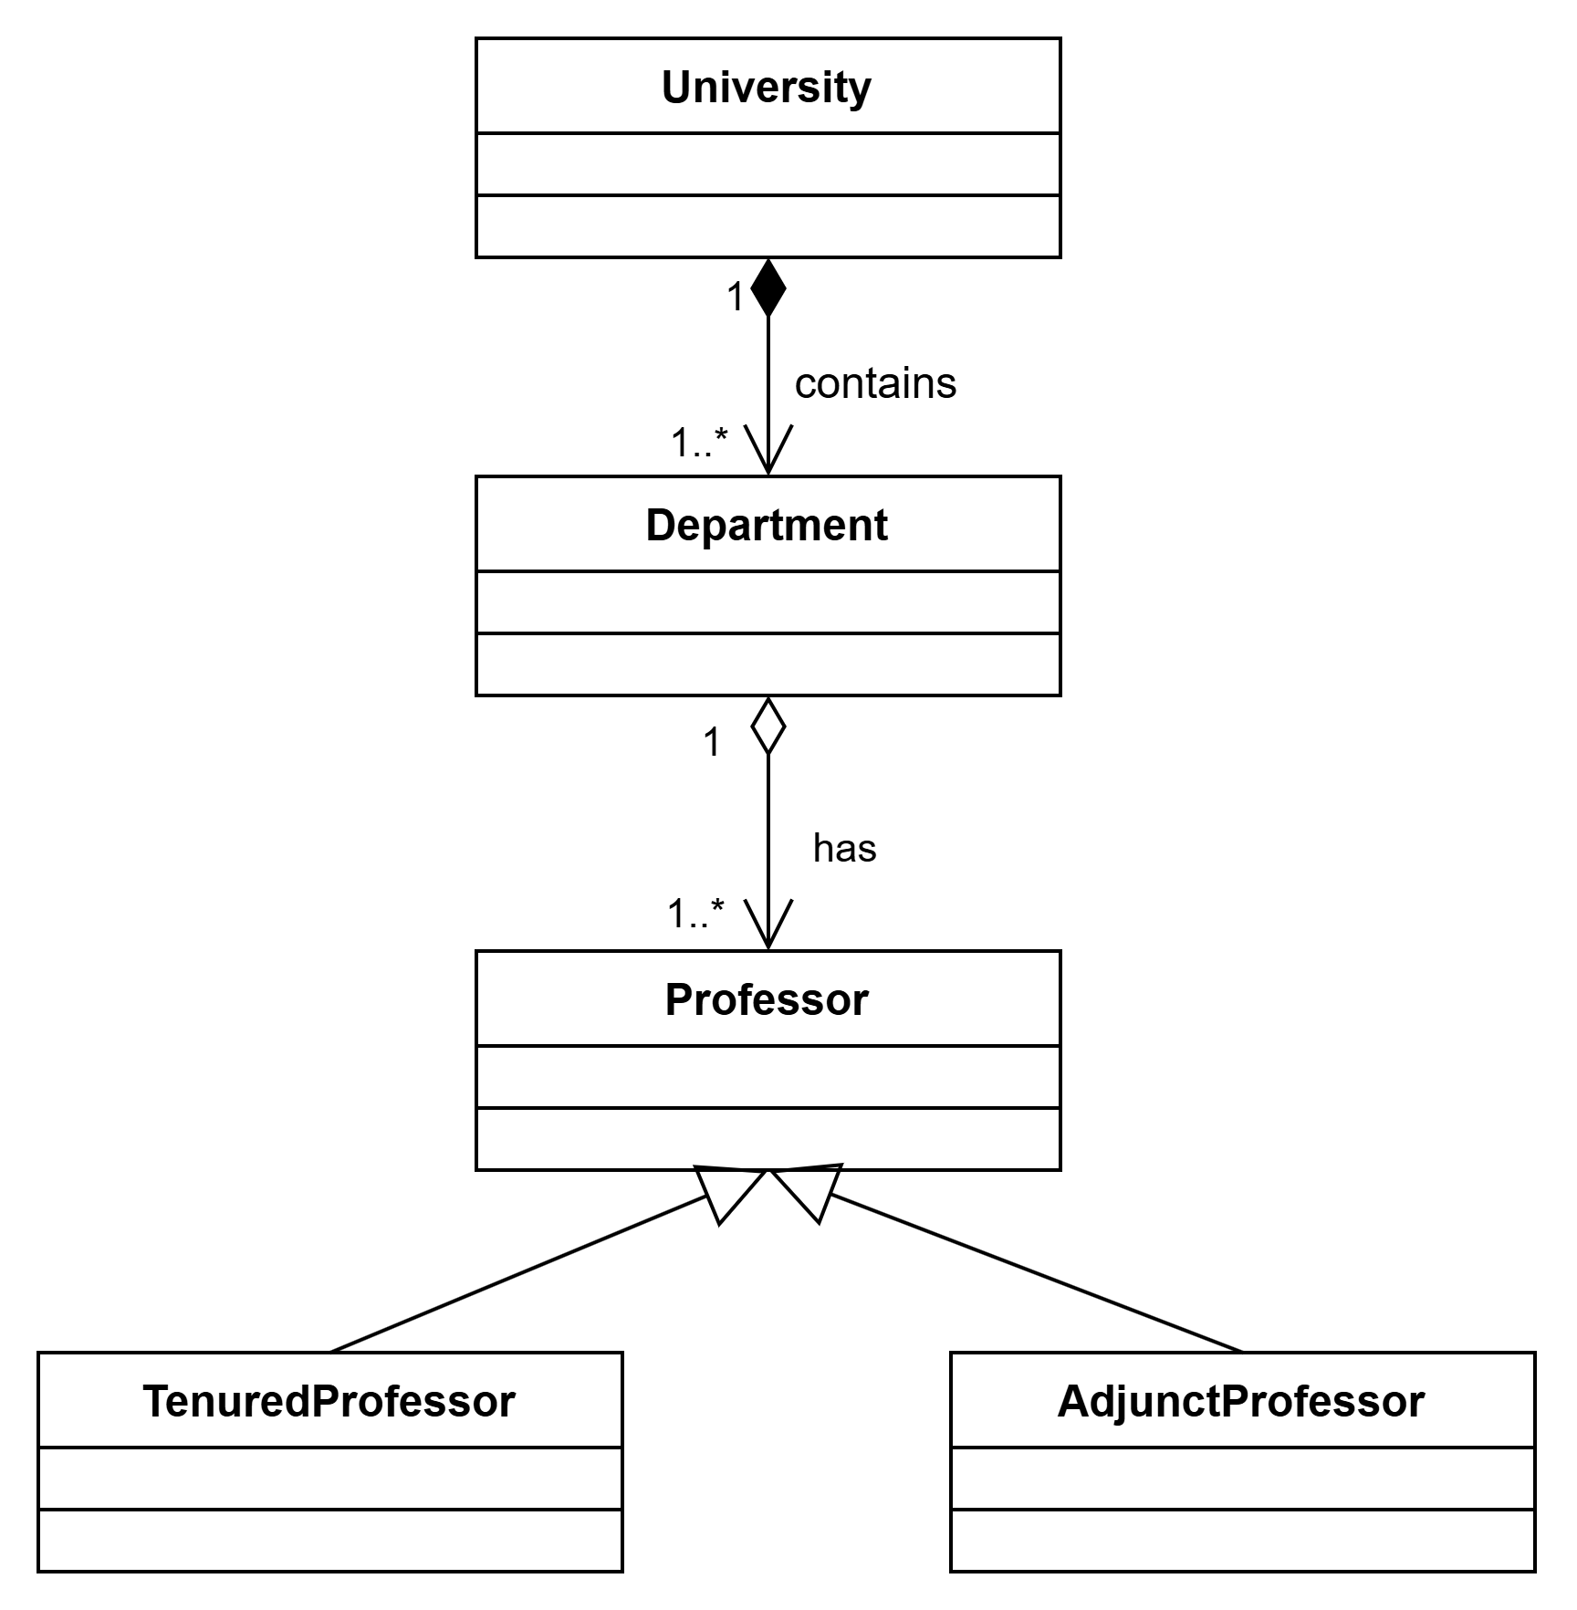
Question 2:

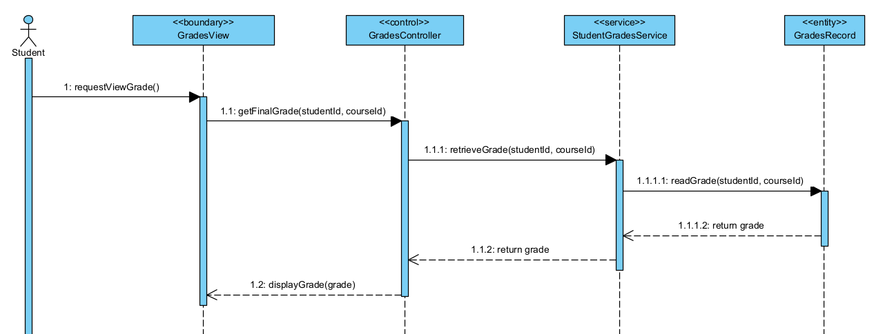
Question 3:

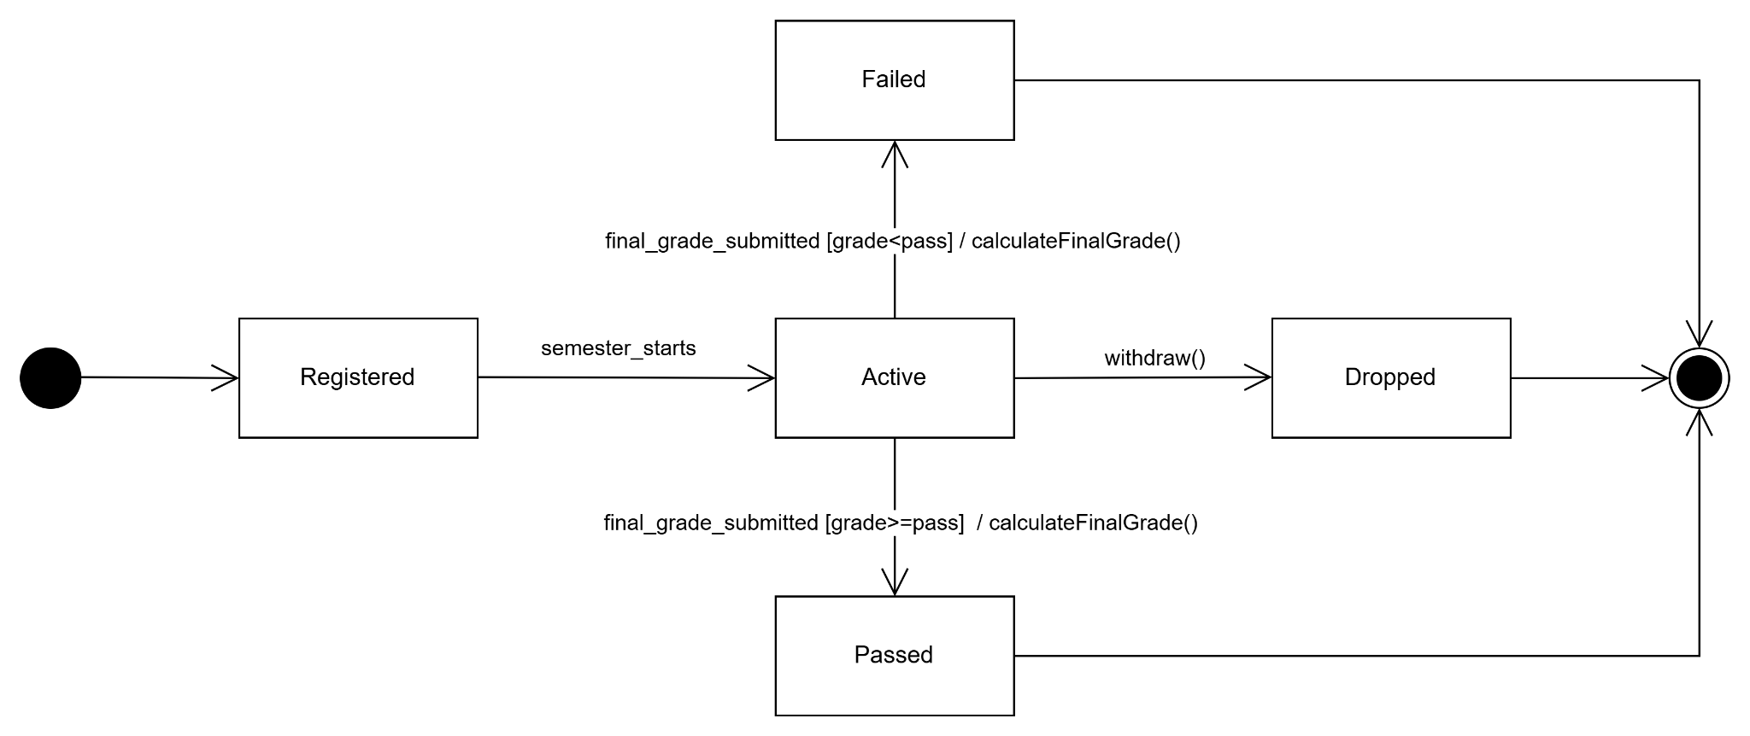

Question 4:
Architecture:
A suitable architecture for the Student Management Administration Portal is the Three-Layer Architecture (Presentation Layer, Business Logic Layer, Data Access Layer).
Advantages:
First, this architecture improves separation of concerns, making the system easier to maintain and modify because each layer has a specific responsibility. Second, it enhances scalability and maintainability, as changes in one layer (for example, the user interface) do not significantly affect the other layers.
Disadvantage:
A potential disadvantage is additional complexity and communication overhead between layers, which may slightly reduce system performance.
Question 5:
Design Pattern: Singleton Pattern
Explanation:
The design pattern ensures that a class has only one instance and provides a global point of access to it. This is useful when multiple parts of the system need to share the same resource such as configuration settings or database connections. This is the classic definition of the Singleton pattern, which restricts object creation to a single instance to maintain consistent state across the application.

END OF SUBMISSION

